**DAILY ONLINE ACTIVITIES SUMMARY**

|  |  |  |  |  |  |  |  |  |
| --- | --- | --- | --- | --- | --- | --- | --- | --- |
| **Date:** | **6th July 2020** | | | | | **Name:** | **Prathusha K A** | |
| **Sem & Sec** | **4th sem &b section** | | | | | **USN:** | **4AL18CS061** | |
| **Online Test Summary** | | | | | | | | |
| **Subject** | | **Complex Analysis, probability and statistical methods.** | | | | | | |
| **Max. Marks** | | **30** | | **Score** | | | **Not provided** | |
| **Certification Course Summary** | | | | | | | | |
| **Course** | **Google cloud platform fundamentals:core infrastructure** | | | | | | | |
| **Certificate Provider** | | | **udemy** | | **Duration** | | | **1 week** |
| **Coding Challenges** | | | | | | | | |
| **Problem statement: write a java program to find the Nth natural number with exactly two bits set.** | | | | | | | | |
| **Status: done** | | | | | | | | |
| **Uploaded the report in Github** | | | | | **yes** | | | |
| **If yes Repository name** | | | | | **https://github.com/prathu47/lockdown-coding** | | | |
| **Uploaded the report in slack** | | | | | **yes** | | | |

Online test Details: (Attach the snapshot and briefly write the report for the same)

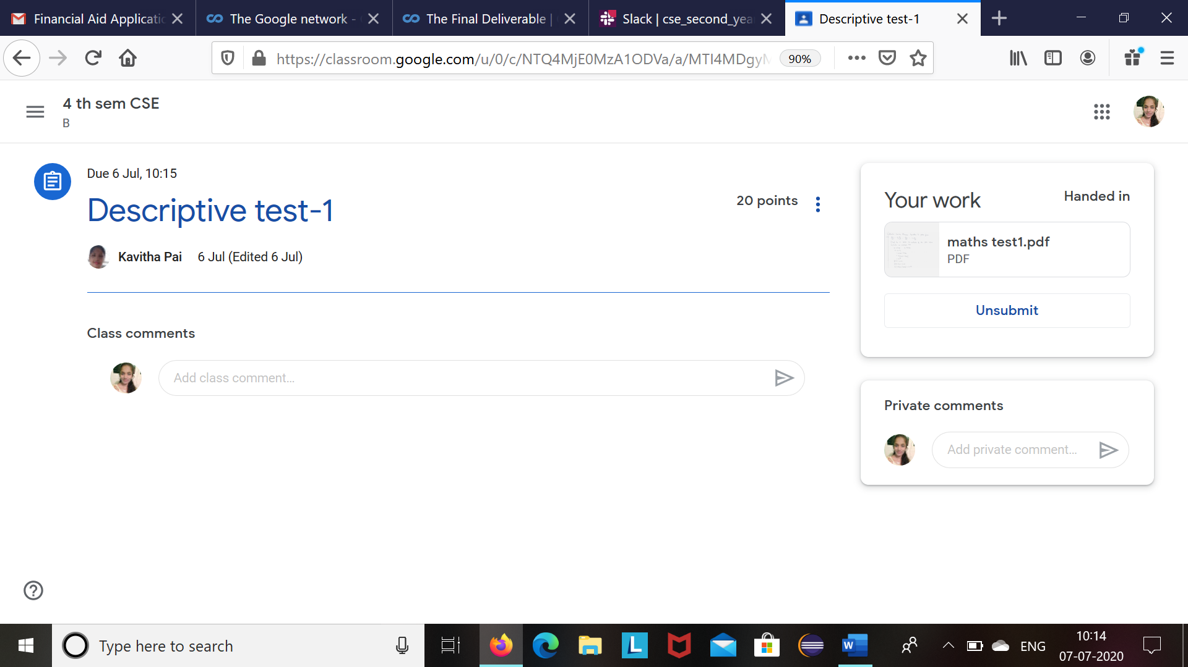

online written IA was conducted today at 9:30AM .The questions was shared at 9:30 in google classroom which is of the time limit 45 minutes. The written answers where scanned and uploaded in google classroom. The above is screenshot of uploaded document.

Certification Course Details: (Attach the snapshot and briefly write the report for the same)

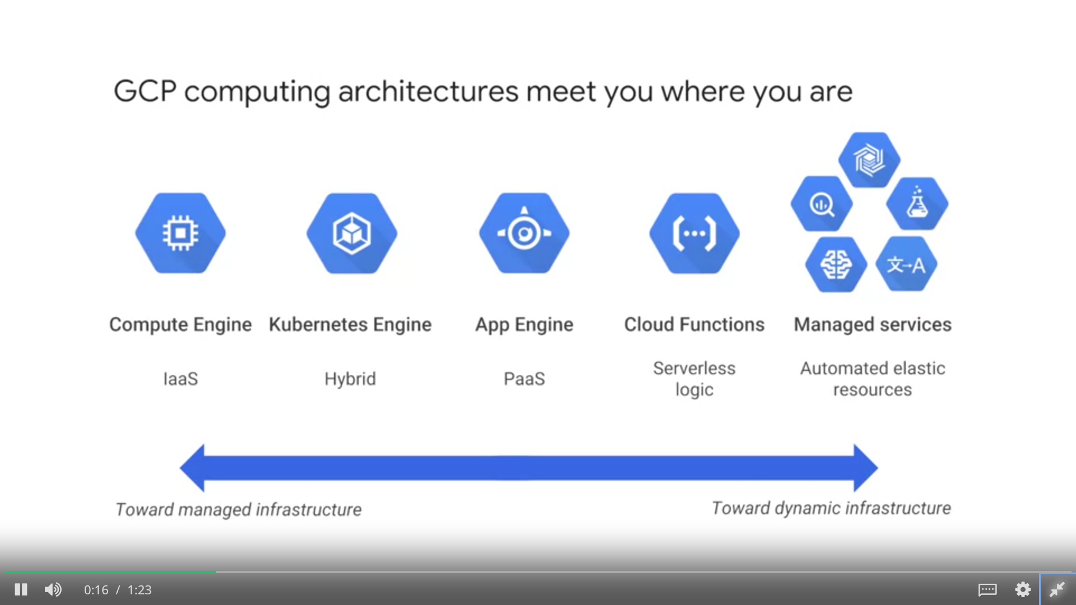

The course I have chosen during the lockdown period is google cloud platform fundamentals.Since I had previously knew few topics about google cloud iam continuing this course . I learnt about google platform It helps me to be perfect in cloud computing.

Coding Challenges Details: (Attach the snapshot and briefly write the report for the same)

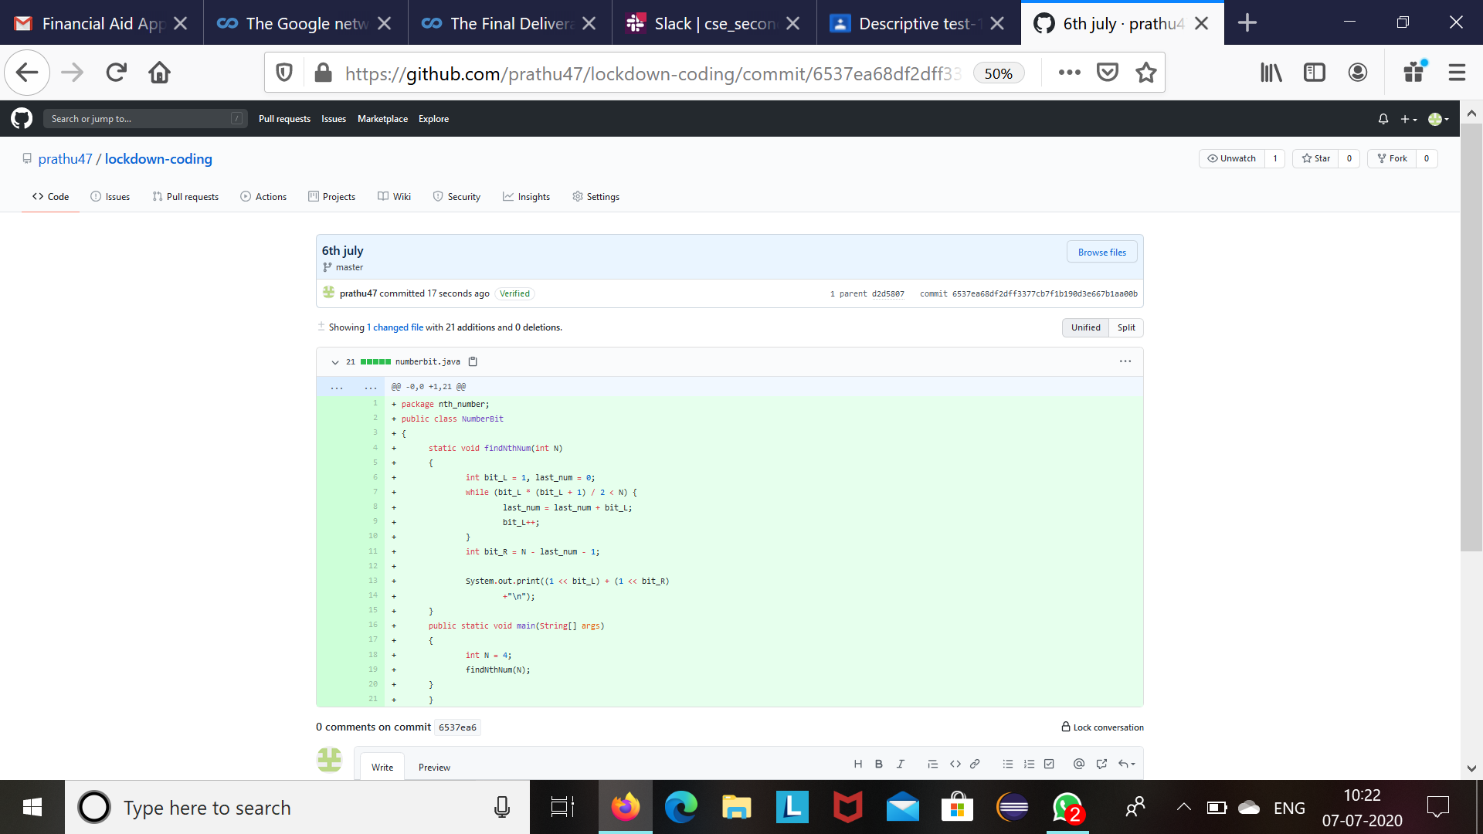

The above is the screeshot of the coding challenge.